**The 6 Hotel & Suites**

**Hotel Booking System**

**Version 1.0**

**Prepared by**

**Group Name: The Boys**

ABELLA, Vincent 18101371 [18101371@usc.edu.ph](mailto:18101371@usc.edu.ph)

BALILI, Mark Huey 19101793 [19101793@usc.edu.ph](mailto:19101793@usc.edu.ph)

BERNALES, Jeff Anthony 19900030 [19900030@usc.edu.ph](mailto:19900030@usc.edu.ph)

INITAN, Johnfil 20102663 [20102663@usc.edu.ph](mailto:20102663@usc.edu.ph)

Date: May 22, 2023

## **Introduction**

## **Document Purpose**

This **Software Requirements Specification** (SRS) document provides a description of the software’s functional and non - functional requirements for The 6 Hotel & Suites | Hotel Booking System, design constraints, and system interfaces.

## **Product Scope**

The 6 Hotel & Suites | Hotel Booking System (HBS) is a website that allows the users to book hotel rooms. The HBS will be utilizing the company database for the staff and customer login details. The system caters to customers where the basic necessary hotel booking system features, descriptions, and policies are included and implemented. The HBS also features authorized staff interactions, the system allows the Admin to assign roles to staff. The software will be incorporated into a website which can be accessed through personal computers and mobile. The approach for this software will be Object-Oriented Programming, since it provides code reusability.

## **Intended Audience and Document Overview**

This document is intended to be used by members of the project team that will implement and verify the correct functioning of the system. This document also aims to capture the stakeholder’s and professor’s preferences and resolutions. In the course of time, this document will then be proposed to the stakeholders on gaining approval and will be used as a reference guide in the different phases of software development.

The following are Intended Audience and Document Overview for Hotel Booking System:

1.3.1 Retirees who desire to spend their retirement funds on a holiday trip.

1.3.2 Families who want to go on a vacation.

1.3.3 Solo travelers who are interested in visiting different countries.

1.3.4 Free Independent Travellers (FITs) whose travels are planned and budgeted, intending to avoid mass tourism in the area.

1.3.5 Couples who want to travel together.

1.3.6 Business travelers in which companies send people to take on business trips

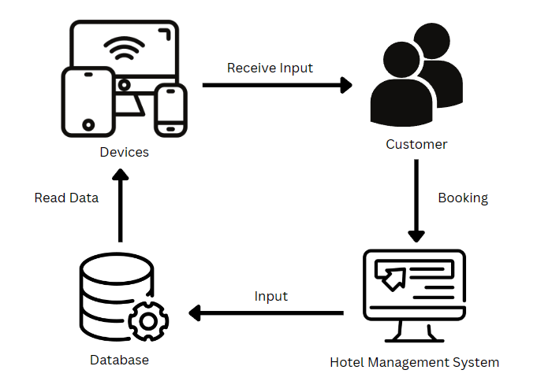

*Figure 1. Customer interaction with HMS*

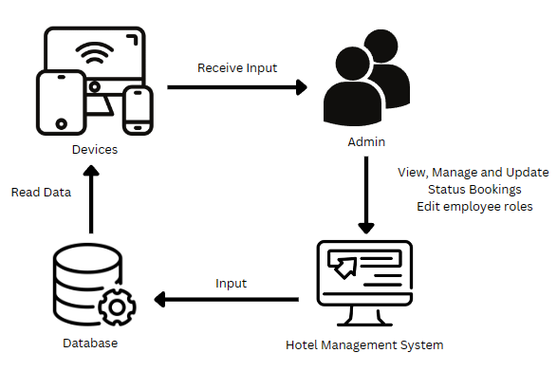

*Figure 2. Admin interaction with HMS*

## **Product Functionality**

These features are available to the user’s browsers:

* Allows user/guest account registration
* Allows user/guest log-in and log-out of the system
* Displays the “Home” tab
  + Displays the introduction, amenities, and socials of the hotel
* Displays the “Book Now” tab
  + Choose options for user booking preferences
    - Room Selections
    - Date Selections
    - Payment Options (asks for card number if chosen)
* Displays the overview based on the user booked preferences

These features are available to the admins’ company computer desktops:

* Allows admin user log-in and log-out of the system
* Creates accounts, View the staff lists, and Manage roles assigned per staff
* Shows existing bookings and status of customer

## **Design and Implementation Constraints**

The Hotel Booking System is developed in **HTML**, **CSS**, and **PHP** using **laravel** framework. The database used is MySQL. The development timeframe is two (2) to three (3) weeks.

The system is a web-based application that requires computers to have web browsers. Clients must be able to easily access the website. The loading of the product should take no more than five minutes. To use the system, one must have a general understanding of basic computer skills.

The following are the constraints in the design and the implementation of the Hotel Booking System (HBS):

* It can only be implemented to hotel booking systems stored in databases

## **Assumptions and Dependencies**

The assumptions in this project are the following:

* The user has any device that has internet connection to access the system
* The user is a computer literate person, is able to navigate through the system
* The company has its own database for the hotel booking system
* The company has an admin that monitors their staffs access to the system

The Dependencies in this project are the following:

* Database for their staff HBS
* Internet connection to access the system

| **Requirement ID** | **Requirements Definition** |
| --- | --- |
| **1** | **Website** |
| 1.1 | Home Tab |
| 1.1.1 | Promotional details of the hotel |
| 1.1.2 | Display amenities: pools, function halls, restaurants |
| 1.2 | Booking Tab |
| 1.2.1 | Show room options: Deluxe, Single, Family, Couples, and Luxury Suite |
| 1.2.2 | Show room pricing |
| 1.2.3 | Duration of stay |
| 1.2.3.1 | Calendar to set available date/s of reservation |
| 1.2.3.2 | Show available rooms (*Note: There are 5 each room option*) |
| 1.2.4 | Prompt “Proceed to Payment” or “Cancel” |
| 1.2.5 | Show payment options |
| 1.2.6 | User Inputs |
| 1.2.6.1 | Personal Information (Name, contact number, email address) |
| 1.2.6.2 | Chosen payment method (cash, visa, bdo) |
| 1.2.6.3 | Card Number (if chosen) |
| 1.2.7 | Prompt “Book Now” or “Cancel” |
| **2** | **System Accounts** |
| 2.1 | “Admin access-level” account |
| 2.1.1 | See staff names together with their roles |
| 2.1.2 | Can assign role to staff |
| 2.1.2.1 | Autosave staff’s inputted details |
| 2.1.2.2 | Choose role of staff |
| 2.1.3 | Show existing/pending bookings |
| 2.1.3.1 | Bookings can be canceled |
| 2.1.3.2 | Bookings can be edited |
| 2.1.3.3 | Checked in |
| 2.1.3.4 | Checked out |

**Task Report - Vincent Abella (Project Lead)**

Project: Web-based Hotel Booking System for The 6 Hotel and Suites

Vincent Abella:

* Assigned tasks and responsibilities to team members based on their expertise.
* Led the project development and ensured coordination and timely task completion.
* Collaborated with stakeholders and provided regular updates on project progress.
* Supported team members in resolving technical and operational challenges.
* Prepared presentation materials and demo scripts to effectively showcase system features and functionalities.

Jeff Anthony Bernales:

* Conducted UI/UX design research and created wireframes and prototypes.
* Enhanced the user experience by incorporating visual elements and ensuring responsiveness.
* Developed an elegant and intuitive user interface that aligns with the hotel's branding and target audience.

Mark Huey Balili:

* Developed comprehensive documentation, including user manuals and system guides.
* Reviewed and revised the documentation for accuracy and clarity.
* Incorporated visual elements and screenshots to support and enhance the content.
* Developed clear and concise documentation, including user manuals, system guides, and technical specifications.

Johnfil Initan:

* Analyzed project requirements and implemented front-end functionalities.
* Conducted testing and debugging to ensure a smooth user experience.
* Developed the database structure using MySQL for efficient data storage and retrieval.
* Implemented front-end functionalities, including user login and registration, homepage layout, and navigation bars.

Collectively:

* Successfully developed and implemented a web-based hotel booking system.
* Created a seamless user experience for guests and efficient management tools for staff.